FINDING FORMULA
Pearson Edexcel - Tuesday 21 May 2019 - Paper 1 (Non-Calculator) Higher Tier
1.
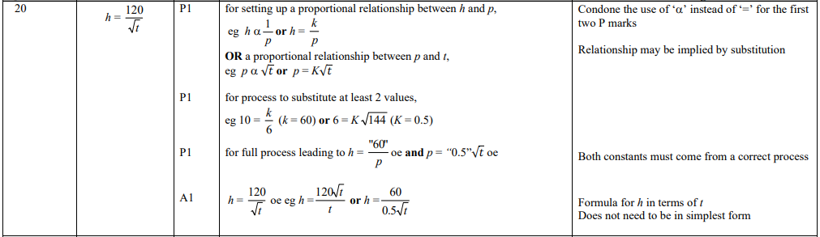
Pearson Edexcel - Thursday 24 May 2018 - Paper 1 (Non-Calculator) Higher Tier
2.
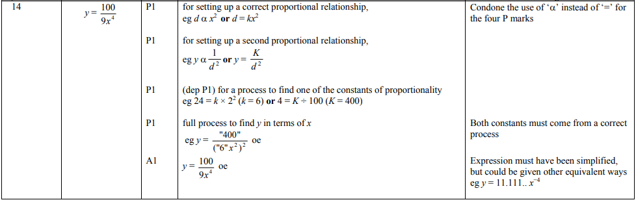
Pearson Edexcel - Thursday 24 May 2018 - Paper 1 (Non-Calculator) Higher Tier
3.
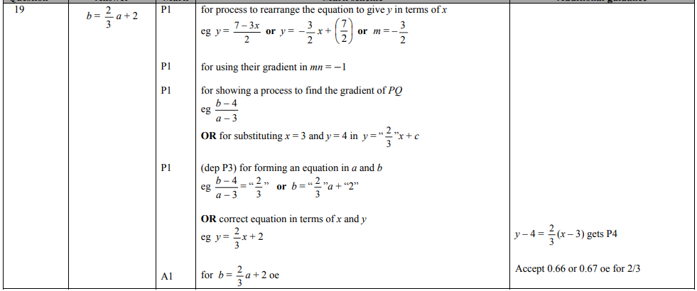
Pearson Edexcel - Specimen Papers Set 2 - Paper 1 (Non-Calculator) Higher Tier
4.
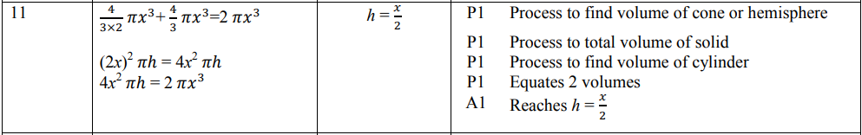
Pearson Edexcel - Thursday 26 May 2016 - Paper 1 (Non-Calculator) Higher Tier
5.
Pearson Edexcel - Wednesday 5 November 2014 - Paper 1 (Non-Calculator) Higher Tier
6.
Pearson Edexcel - Friday 2 March 2012 - Paper 3 (Non-Calculator) Higher Tier
7.
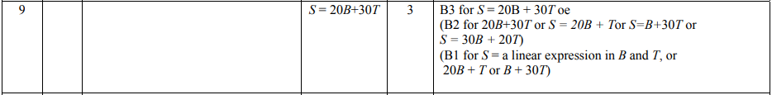
Pearson Edexcel - Monday 6 June 2011 - Paper 3 (Non-Calculator) Higher Tier
8.
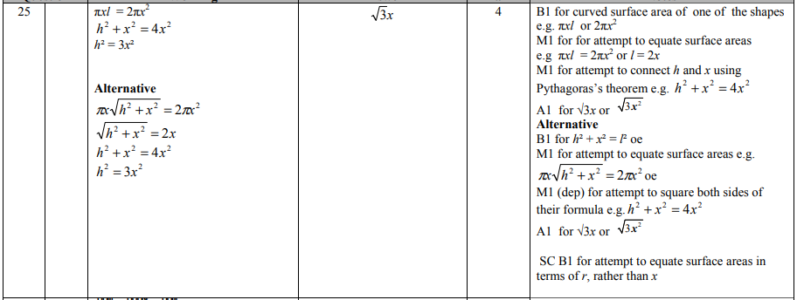
Pearson Edexcel - Friday 12 November 2010 - Paper 4 (Calculator) Higher Tier
9.
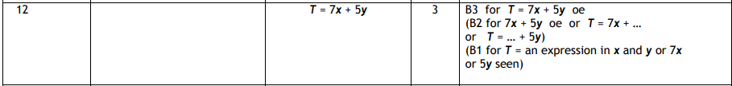
Pearson Edexcel - Thursday 5 November 2009 - Paper 3 (Non-Calculator) Higher Tier
10.
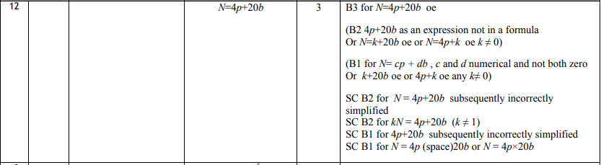
Pearson Edexcel - Tuesday 10 November 2009 - Paper 4 (Calculator) Higher Tier
11.
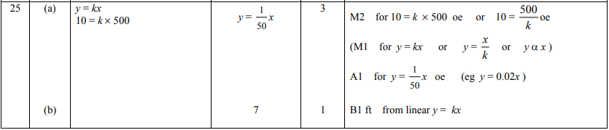
AQA GSCE – Wednesday 8 November 2017 – Paper 3 (Calculator) Higher Tier
12.
